[E133] Solid state relays

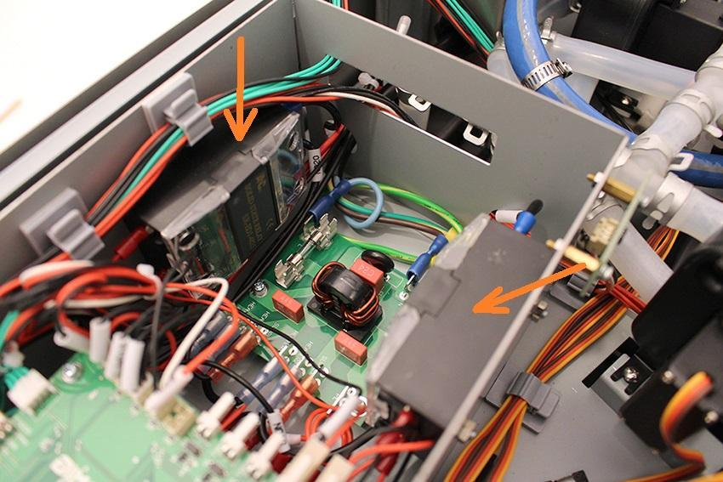

Bend carefully the back of the cover to grab the locknuts shown on the right picture. Grab them with pliers and unscrew the screws indicated on the left picture.

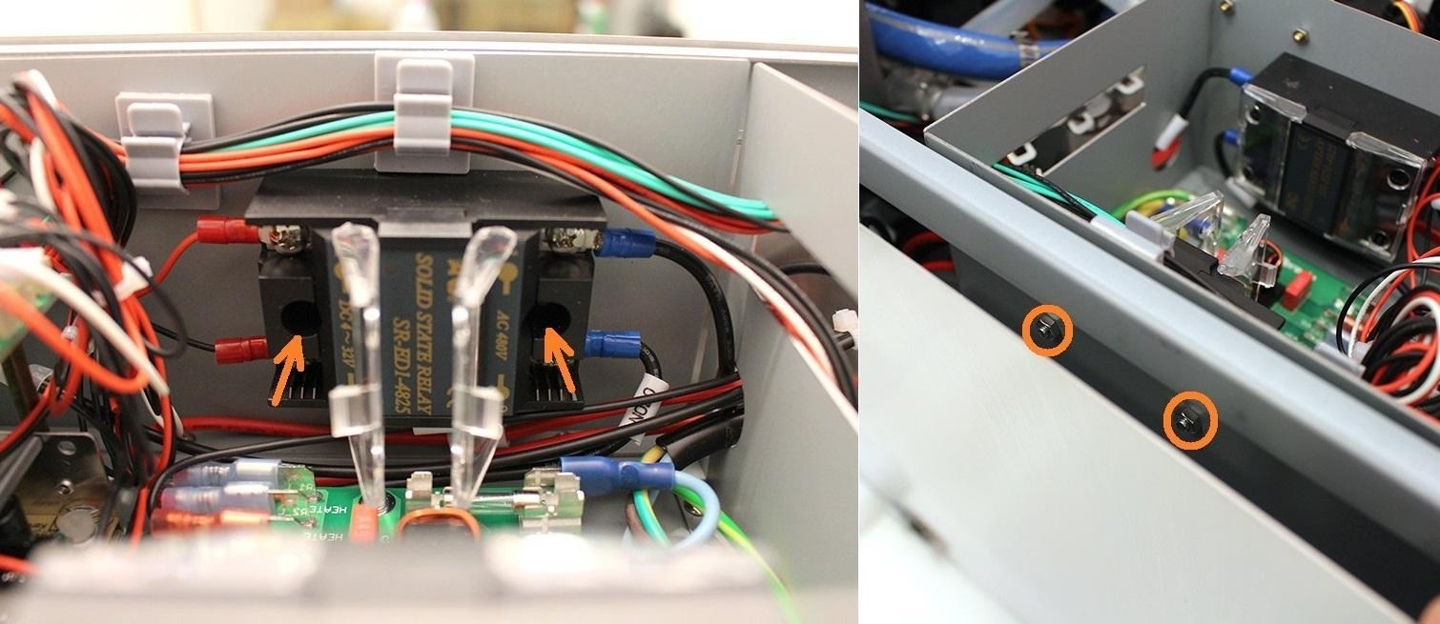

Grab the locknuts with pliers and unscrew the screws indicated on the left picture.

